Progress of sowing and agricultural crops details During Summer Season 2021-22.
(05.02.2022)

2021-22 Agricultural Production:

Anticipating timely and well distributed rainfall during pre-monsoon, southwest & northeast monsoon period in 2021-22 it was programmed to cover 77.00 lakh hectares, 28.00 lakh hectares and 5.00 lakh hectares during Kharif, Rabi and Summer seasons respectively, totally 110.00 lakh hectares under agricultural crops. Proposed production target for Food grains and Oilseeds were 135.48 lakh tonnes and 15.23 lakh tonnes respectively.

Sl.No. | Crops | Area (Lakh Hectares) | Production (Lakh Tonnes)
1. | Cereals | 45.91 | 112.69
2. | Pulses | 33.84 | 22.79
 | Total Food Grains | 79.76 | 135.48
3. | Oilseeds | 15.08 | 15.23
4. | Commercial Crops
i) | Cotton | 7.77 | 21.37 Lakh Bales
ii) | Sugarcane | 6.68 | 521.97
iii) | Tobacco-VFC | 0.71 | 0.64
 | Total Area | 110.00

2021-22 Kharif Agricultural Production:

During Kharif 2021 total of 77.00 lakh hectares area has been set as target for sowing under different crops.

Sl.No. | Crops | Area (Lakh Hectares) |  | Production (Lakh Tonnes)
 |  | Targeted Area | Sown Area
1. | Cereals | 31.37 | 33.67 | 87.73
2. | Pulses | 21.07 | 21.18 | 14.16
 | Total Food Grains | 52.44 | 54.85 | 101.88
3. | Oilseeds | 10.67 | 10.11 | 10.85
4. | Commercial Crops
i) | Cotton | 7.30 | 6.39 | 21.04 Lakh bales
ii) | Sugarcane | 5.88 | 6.39 | 455.80
iii) | Tobacco-VFC | 0.71 | 0.76 | 0.64
 | Total Area | 77.00 | 78.72
2021-22 Rabi Agricultural Production:

During Rabi 2021 total of 28.00 lakh hectares area has been set as target for sowing under different crops.

Sl.No. | Crops | Area (Lakh Hectares) |  | Production (Lakh Tonnes)
 |  | Targeted Area | Sown Area
1. | Cereals | 11.92 | 10.22 | 16.43
2. | Pulses | 12.69 | 12.27 | 8.62
 | Total Food Grains | 24.61 | 22.49 | 25.05
3. | Oilseeds | 2.50 | 2.50 | 2.29
4. | Commercial Crops
i) | Cotton | 0.46 | 0.23 | 0.31 Lakh bales
ii) | Sugarcane | 0.43 | 0.83 | 37.74
iii) | Tobacco-VFC | 0.00 | 0.00 | 0.00
 | Total Area | 28.00 | 26.05

2021-22 Summer Agricultural Production:

During Summer 2021 total of 5.00 lakh hectares area has been set as target for sowing under different crops.

Sl.No. | Crops | Area (Lakh Hectares) |  | Production (Lakh Tonnes)
 |  | Targeted Area | Sown Area
1. | Cereals | 2.62 | 0.89 | 8.53
2. | Pulses | 0.09 | 0.02 | 0.02
 | Total Food Grains | 2.70 | 0.91 | 8.55
3. | Oilseeds | 1.91 | 0.22 | 2.08
4. | Commercial Crops
i) | Cotton | 0.01 | 0.00 | 0.02
ii) | Sugarcane | 0.37 | 0.08 | 28.43
iii) | Tobacco-VFC | 0.00 | 0.00 | 0.00
 | Total Area | 5.00 | 1.21

Rainfall:
Pre-monsoon rainfall:
During 2021-22 normal Pre-monsoon rainfall (March-1 to May-31) was 115 mm against actual rainfall 166 mm (44 %).
Southwest monsoon rainfall:

Southwest monsoon (June-1 to September-30) normal average rainfall was 852 mm against actual rainfall 787 mm (-8%).

North-East monsoon rainfall:

Northeast monsoon (October-1 to December-30) normal average rainfall was 182 mm against actual rainfall 342 mm (88%).

Totally (January-1 to December-30) normal average rainfall was 1153 mm against actual rainfall 1337 mm (16%).

Rainfall 2022:

February-1 to February-5 normal average rainfall was 2 mm against actual rainfall 1 mm.(-52%). District wise rainfall data is attached in Annexure-1.

Kharif 2021 Area coverage:

During Kharif 2021 total of 78.72 lakh hectares (102%) has been sown against a set target of 77.00 lakh hectares.

Totally 14.40 lakh hectares crop damages due to heavy rains/flood in 28 districts.

Rabi 2021 Area coverage:

During Rabi 2021 total of 26.05 lakh hectares (93%) has been sown against a set target of 28.00 lakh hectares.

Summer 2021 Area coverage:
During Summer 2021 total of 1.21 lakh hectares (24%) has been sown against a set target of 5.00 lakh hectares by 05.02.2022, Crop wise and district wise area sown details was provided in annexure 2 and 3.

Supply of Agricultural Tools:

Seeds and fertilizer are the main agricultural commodities for farmers for distribution at Raitha Samparka Kendra (RSK) in all taluks.
Seeds:

For Rabi 2021-22, 3.53 lakh qtls seeds were estimated as demand for sowing and till dated:31.01.2022, 2.74 lakh qtls seeds have been distributed at Raitha Samparka Kendras (RSK). Remaining balance of 17069.16 qtls stock is available at RSK .

Fertilizer:

For Rabi 2021-22, total fertilizer demand was estimated at 16.94 lakh metric tonnes and arrangement has been made for timely implementation at various stages till 05.02.2022 total of 10.20 lakh metric tonnes fertilizer has been supplied and the available stock is 6.03 lakh metric tonnes.

ANNEXURE -1
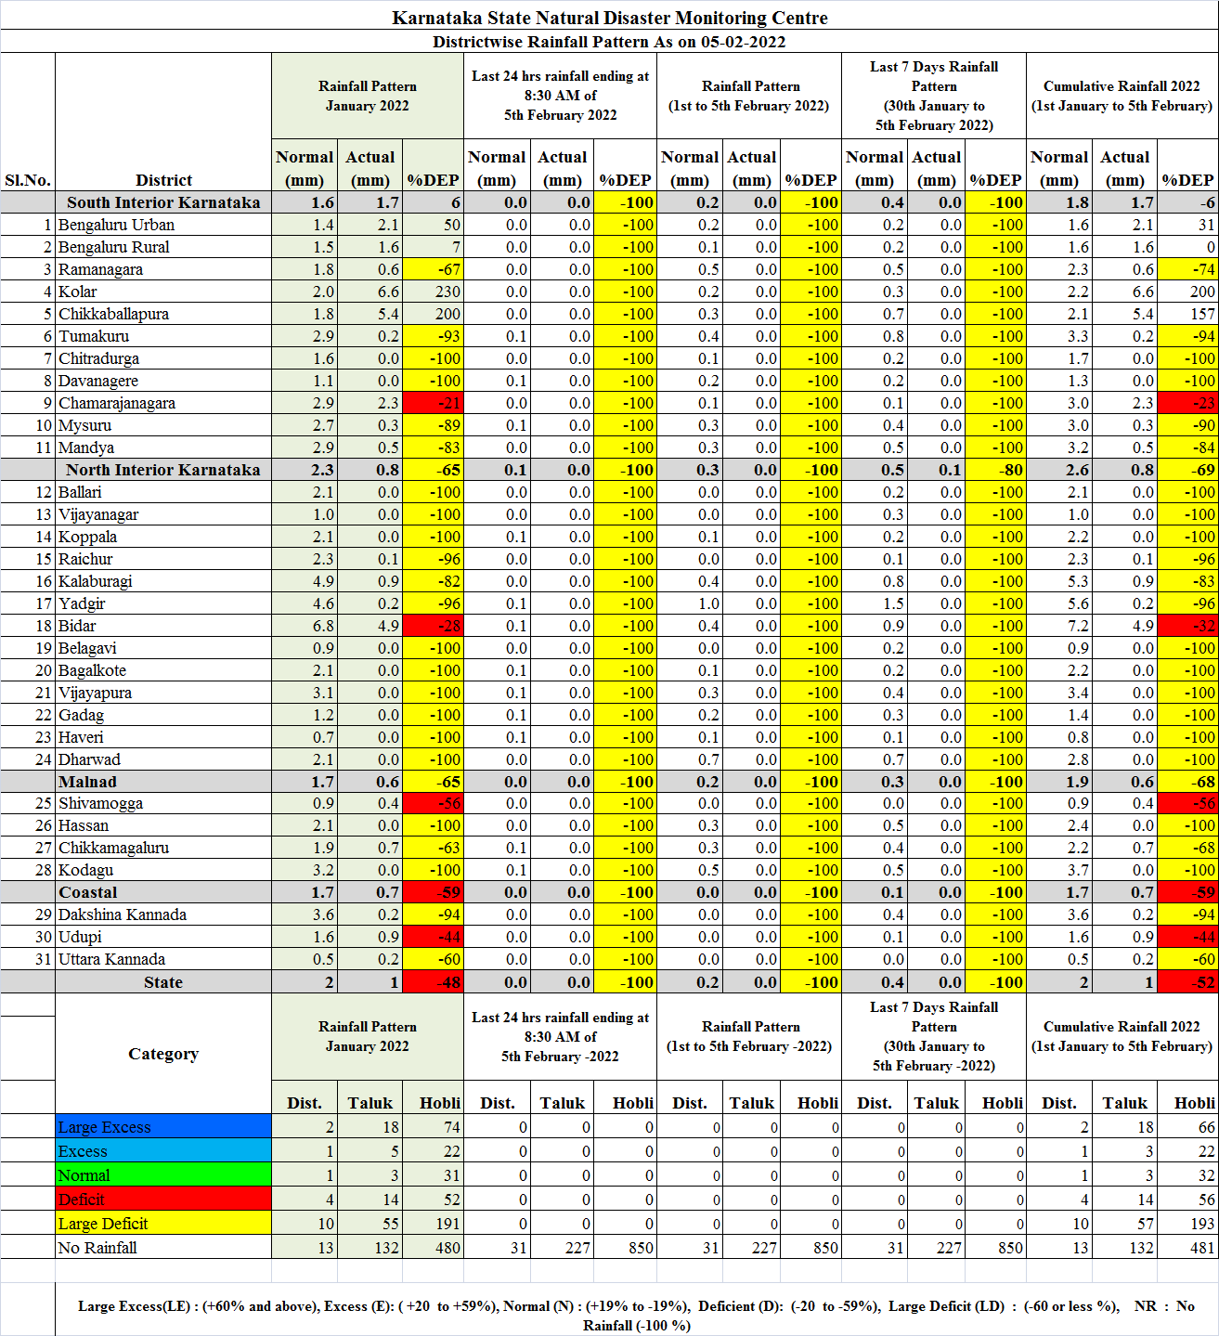
ANNEXURE -2
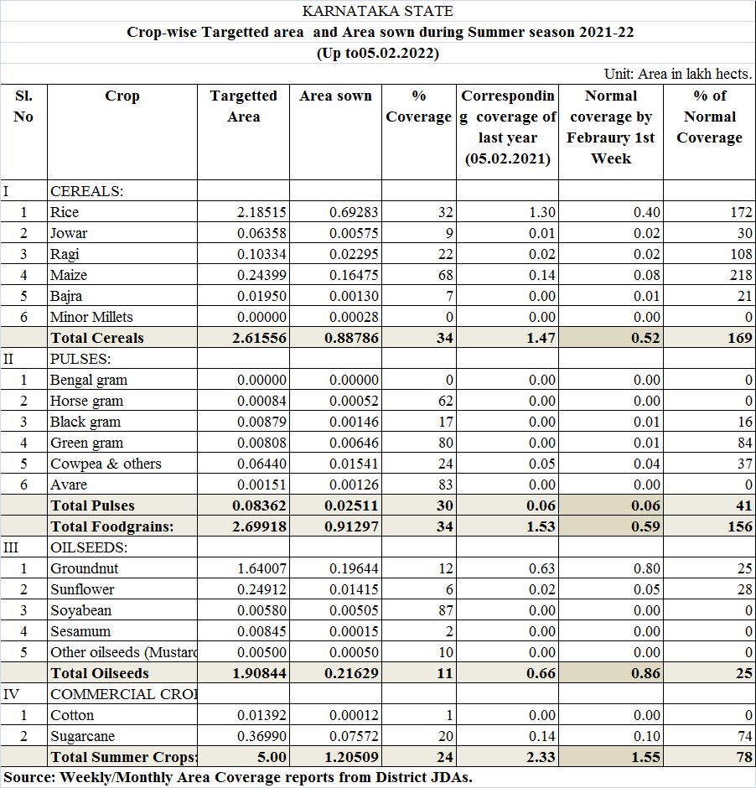
ANNEXURE -3
